SWEDESBORO-WOOLWICH HISTORICAL SOCIETY
INVITES YOU TO
A SPECIAL PRESENTATION
“WHAT WAS IT LIKE?
REMEMBERING
RICHARDSON AVENUE SCHOOL”
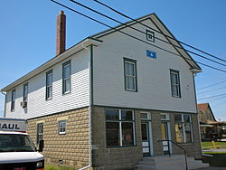

WEDNESDAY, OCTOBER 21, 2015
7:00 PM
At the Swedesboro Municipal Building/Courtroom
1500 Kings Highway, Swedesboro, NJ
FIND OUT FIRST HAND FROM THOSE WHO ATTENDED!
THIS PROGRAM IS SPONSORED IN CONJUNCTION WITH H.E.L.P., INC.
Call 856-467-1693 for more information

