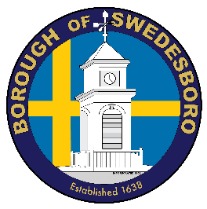**BOROUGH OF SWEDESBORO**

COUNTY OF GLOUCESTER

Borough of Swedesboro  
1500 Kings Highway

Swedesboro, NJ 08085

(856) 467-0202 (phone)

(856) 467-5767 (fax)

From the Office of the Mayor,

On Saturday, June 6th, a “Swedesboro Solidarity March” will be taking place in town.  Please consider joining us or possibly lining Kings Highway from Lake Avenue to Mechanic Street to show that the town of Swedesboro supports unity and peaceful protest during these turbulent times.  If you want to join please meet at Locke Avenue Park (please arrive by 10:45 am). March will begin promptly at 11 am and will proceed north on Auburn Avenue to Kings Highway and then continue south on Kings Highway to Mechanic before ending up back at the Locke Avenue Park where a prayer vigil will be held.

I met with the amazing young women who are organizing this march and they make it clear that this is a march of solidarity with our police department, police chaplains, our residents and Borough officials to show unity in our community and stand against injustice in a peaceful manner.  I could not be more proud of these Kingsway graduates and future leaders.

While NJ is continuing to loosen restrictions related to COVID it’s important that we protect ourselves and our families by wearing a face mask and maintaining strict adherence to social distancing guidelines during this march.  Showing solidarity is extremely important but so is our health, so we strongly encourage everyone involved to follow social distancing guidelines and wear a face mask.

I personally support this march/protest 100% and strongly believe that we should all be outraged by what happened to George Floyd and the continuing systemic racial injustice that unfortunately is still prevalent in our country.  We have to do better as Americans in 2020. Our beautiful community is not immune to what is happening across the country and I hope that we can use this march to show others how a community can come together in unity to demand the needed changes that have to take place to make us a truly united country finally.

Swedesboro United.

Tom Fromm