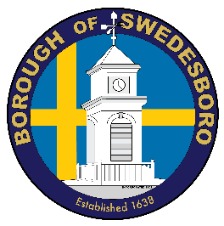**BOROUGH OF SWEDESBORO**

COUNTY OF GLOUCESTER

Borough of Swedesboro  
1500 Kings Highway

Swedesboro, NJ 08085

(856) 467-0202 (phone)

(856) 467-5767 (fax)

**PUBLIC NOTICE  
BOROUGH OF SWEDESBORO**

**LAND USE BOARD MEETING August 10, 2020**

In accordance with the Open Meeting Act, P.L. 1975 c 231, *N.J.S.A.* 10:4-6, *et. seq.,* this is to advise that the Land Use Board of the Borough of Swedesboro, Gloucester County, New Jersey, will hold a **public meeting** on **Monday,** **August 10, 2020 at 7:00PM by way of electronic communication/live streaming pursuant to *N.J.S.A.* 10:4-8(b) and consistent with Executive Order 103 signed by Governor Murphy on March 9, 2020 in an abundance of caution and to help prevent the spread of COVID-19. The** Meeting will be open for public comment end of the meeting when directed**. The Land Use Board Meeting will be broadcast live via Cisco WebEx, you may access the meeting via the**

[**https:\\swedesboro.webex.com**](https://swedesboro.webex.com)

|  |  |
| --- | --- |
| **Event/meeting number: 129 607 3617** |  |
| **Event/meeting password: Plan0810** |  |

**Or Via Telephone 1-408-418-9388, then Event/meeting number: 129 607 3617**

**Residents can view the meeting as detailed above. The Land Use Board will hold this meeting via online meeting forum and telephone conference and will not be in-person. This meeting will be closed to any in-person attendance except for essential individuals for broadcasting**

Formal action will be taken.

Lois Yarrington

Secretary