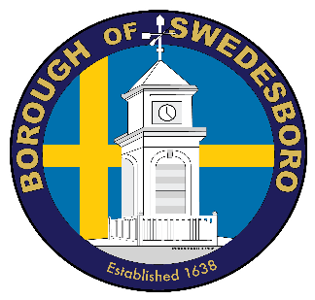
BOROUGH OF SWEDESBORO
COUNTY OF GLOUCESTER

Borough of Swedesboro
1500 Kings Highway
Swedesboro, NJ 08085
856- 467-0202 (Phone)
856- 467-5767 (Fax)

PUBLIC NOTICE
BOROUGH OF SWEDESBORO
PLANNING/ZONING BOARD MEETING
December 14, 2020

In accordance with the Open Meeting Act, P.L. 1975 c 231, N.J.S.A. 10:4-6, et. seq., this is to advise that the Planning/Zoning Board of the Borough of Swedesboro, Gloucester County, New Jersey, will hold a public meeting on Monday, December 14, 2020 at 7:00PM by way of electronic communication/live streaming pursuant to N.J.S.A. 10:4-8(b) and consistent with Executive Order 103 signed by Governor Murphy on March 9, 2020 in an abundance of caution and to help prevent the spread of COVID-19. The Meeting will be open for public comment end of the meeting when directed. The Land Use Board Meeting will be broadcast live via Microsoft Teams, you may access the meeting via the

Join Microsoft Teams Meeting

Residents can view the meeting as detailed above. The Planning/Zoning Board will hold this meeting via online meeting forum and telephone conference and will not be in-person. This meeting will be closed to any in-person attendance except for essential individuals for broadcasting
Formal action will be taken.

Lois Yarrington
Secretary

BOROUGH OF SWEDESBORO
COUNTY OF GLOUCESTER

Borough of Swedesboro
1500 Kings Highway
Swedesboro, NJ 08085
856- 467-0202 (Phone)
856- 467-5767 (Fax)

BOROUGH OF SWEDESBORO
Planning/Zoning Board Agenda
December 14, 2020

Call to Order

Roll Call

Sunshine Law

Salute to Flag

Review & Approve Minutes of September 14, 2020

Memorialize Resolutions –None
2020-09 Botto’s Italian Line Restaurant
Minor Site Plan Amendment

2020-10 Swedes Plaza, LLC
Site Plan Waiver

2020-11 Darmaur Properties, LLC
Amended Site Plan Waiver

Old Business – None

New Business/Applications

Correspondence-
Maley Givens-Attorney for the Borough of Swedesboro in regards to the Extension of Minor Subdivision Approval

Open to the public

Adjourn Meeting

