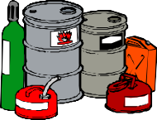
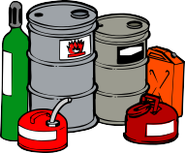

GLOUCESTER COUNTY
2022 HOUSEHOLD SPECIAL WASTE COLLECTION DAYS

LOCATION

Gloucester County Solid Waste Complex 493 Monroeville Road (Rt. 694), South Harrison
Dates: April 9, 2022

September 17, 2022
All events: 8:00 am - 2:00 pm (RAIN or SHINE)

LOCATION

Gloucester County Road Department 1200 N. Delsea Drive (Rt. 47), Clayton
Dates: May 21, 2022

October 29, 2022(NEW DATE)
All events: 8:00 am - 2:00 pm (RAIN or SHINE)

Materials Accepted:
Oil based paints, stains, motor oil, antifreeze, CFL bulbs, fluorescent bulbs, ballasts, lead acid, Ni-cad, lithium, & all rechargeable batteries, fire extinguishers, solvents, pesticides, cleaners, kerosene, herbicides, gasoline, turpentine, varnish, fertilizers, rat poison, auto & floor care products, weed killers, lighter fluid, propane tanks, photographic & pool chemicals.
55 gallon containers REQUIRE prior approval.

NO LATEX PAINT or ALKALINE BATTERIES ACCEPTED!
Due to increasing costs, NO latex paint will be accepted at any events. Latex is water based & non-hazardous when dry. Please dry out cans with kitty litter and dispose in regular trash.
Alkaline non-rechargeable batteries may also be placed in the regular trash.
For more information see our website www.gcianj.com

FOR INFORMATION CALL 478-6045
Participation limited to Gloucester County residents ONLY!
Commercial businesses are prohibited from participating in these events!

Sponsored by the Gloucester County Improvement Authority/Office of Recycling &
the Gloucester County Board of Commissioners, Frank J. DiMarco, Director
The GCIA is an equal opportunity/ADA compliant government agency.

