MATERIALS ACCEPTED FOR DISPOSAL

Materials will only be accepted for each scheduled event at the designated drop-off site and time. Items WILL NOT be accepted at any other location!
Acceptable items include: oil based paints, stains, motor oil, antifreeze, lead acid, Ni-cad, lithium and all rechargeable batteries, fire extinguishers, CFL bulbs, fluorescent bulbs, ballasts, solvents, pesticides, cleaners, kerosene, herbicides, gasoline, turpentine, varnish, fertilizers, rat poisons, auto and floor care products, weed killers, lighter fluid, propane tanks, photographic and pool chemicals. (All 55 gallon containers require prior approval)
The following items will NOT be accepted for disposal: latex paint, alkaline batteries, PCBs, infectious waste, medical waste, radioactive waste , ammunition & explosives.
2022
HOuSEHOLD SPECIAL WASTE COLLECTIOn dates

GLOuCESTER COunTy'S HOuSEHOLD SPECIAL WASTE PROGRAM . . .
Since 1989 Gloucester County has been conducting collection days where residents can drop-off their "Household Special Waste" (HSW) at a designated location for free. The Gloucester County Improvement Authority (GCIA)/Office of Recycling, in cooperation with the Gloucester County Board of Commissioners, continues these drop-off HSW Events to provide a free convenient disposal method for Gloucester County residents. In 2022, Gloucester County will sponsor four collection events. Over the years, Gloucester County's HSW Program has accepted thousands of pounds of hazardous materials, removing them from the regular waste stream.
Due to the extensive costs associated with the

LOCATION:
Gloucester Co. Solid Waste Complex, 493 Monroeville Rd. (Rt. 694), S. Harrison

Dates: April 9, 2022
September 17, 2022

(All events: 8:00 am - 2:00 pm)

RAIN or SHINE

HSW Program, the present four day schedule is the most the GCIA/Office of Recycling can offer
and still remain within budgetary constraints.

THE 2022 HSW COLLECTION DAYS ARE LIMITED TO GLOUCESTER COUNTY RESIDENTS ONLY!!

COMMERCIAL BUSINESSES ARE PROHIBITED FROM PARTICIPATING IN THESE EVENTS!!
For further information contact GCIA/Office of Recycling
(856) 478-6045
Web site: www.gcianj.com

LOCATION:
Gloucester County Road Department, 1200 North Delsea Dr. (Rt. 47), Clayton

Dates: May 21, 2022
October 29, 2022(NEW DATE)

(All events: 8:00 am - 2:00 pm)

RAIN or SHINE

NO TIRES OR ASBESTOS PRODUCTS WILL BE ACCEPTED.
For tire disposal contact (856) 478-6045
For asbestos disposal contact (856) 478-6045

Latex paint will NOT be accepted for disposal! It is awater based paint & considered NON-HAZARDOUS when dried out.
For those of you who have empty latex paint cans, please take the lids off and place them in your regular household trash. For those cans that still have paint in them: if the latex paint has solidified, that too can be placed in the trash with the lids off. Kitty litter or any other clay based quick dry product may be used to dry out any remaining liquid paint that is left. Place the hardened paint can in the trash as above. If we all work together, we can keep HSW disposal costs down and continue our HSW Collections for many years to come.

GLOuCESTER COunTy HOuSEHOLD
SPECIAL WASTE
COLLECTIOn SCHEDuLE
2022
This is the only 2022 collection schedule that will be available PLEASE DO NOT DISCARD!
SPONSORED BY:
Gloucester County Improvement Authority/ Office of Recycling
Gloucester County
Board of Commissioners
Frank J. DiMarco, Director
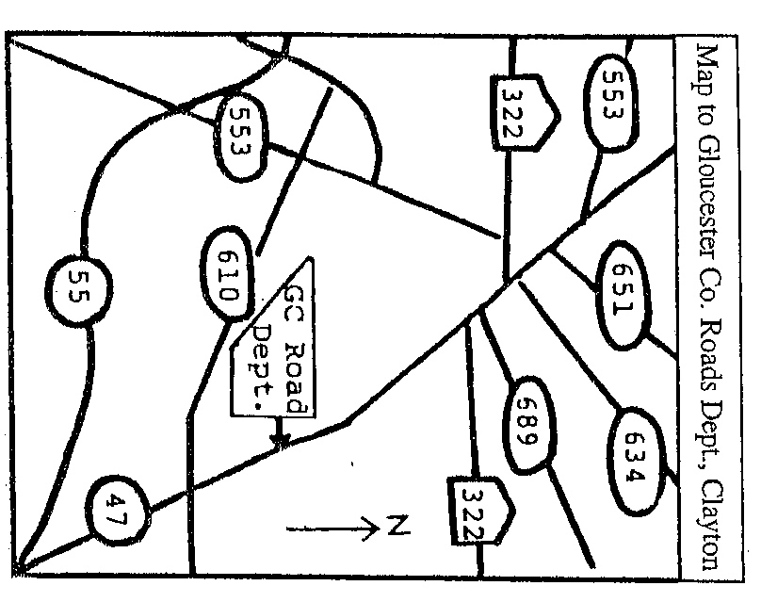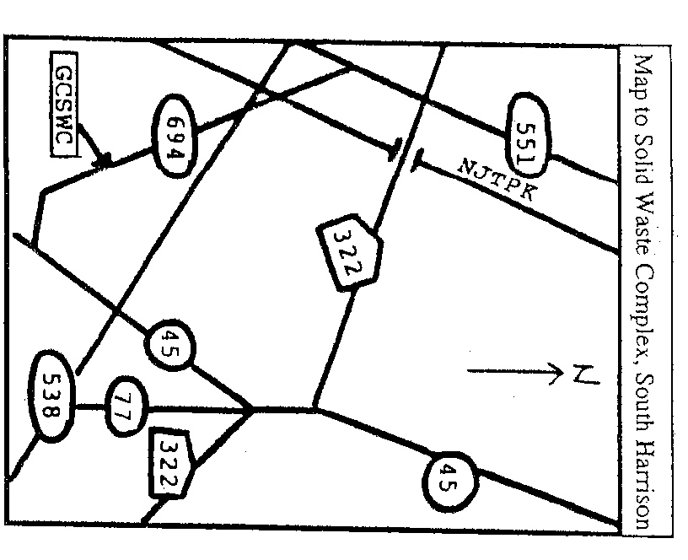

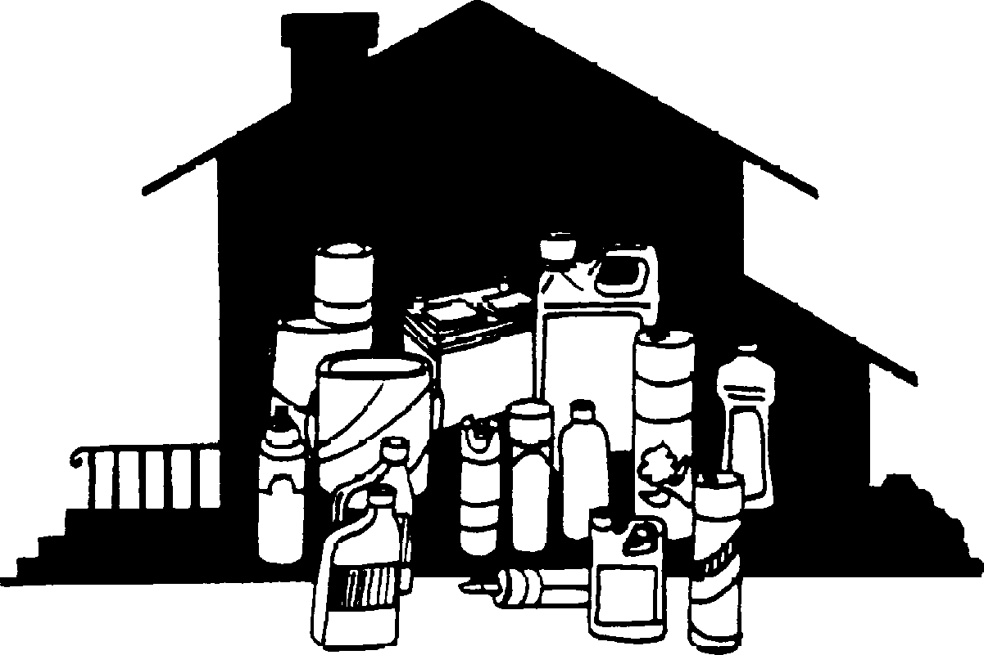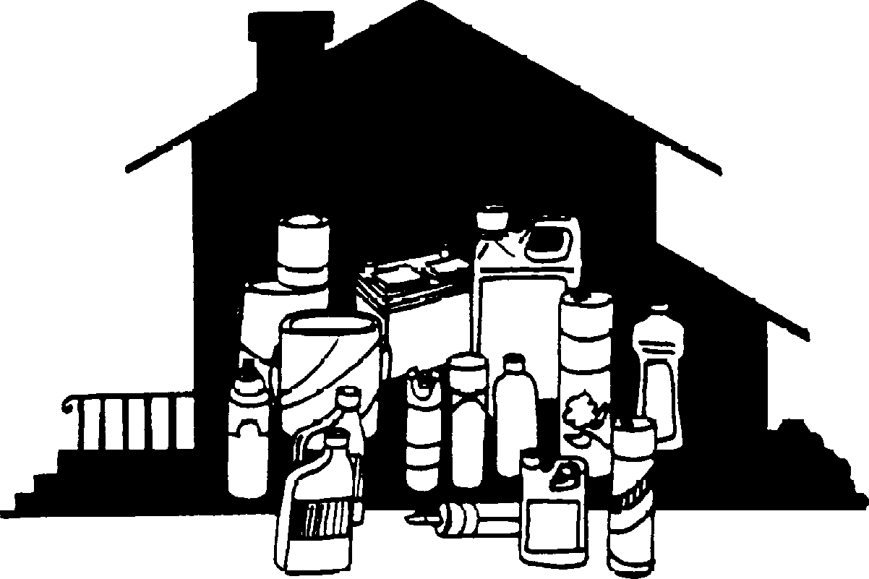
CLEAN OUT THOSE BASEMENTS & GARAGES
This pamphlet contains the entire 2022 schedule for Gloucester County's Household Special Waste Program

The Gloucester County Improvement Authority complies with all state and federal rules and regulations and does not discriminate on the basis of race, religion, color, national or ethnic origin, sexual orientation, age, marital status or disability in admission to, access to, or operations of its programs, services, or activities. In addition, Gloucester County Improvement Authority encourages the participation of people with disabilities in its programs and activities. Inquiries regarding compliance may be directed to the EEO Officer at 856-848-4002.

